PRESS RELEASE

Christophe de la Fouchardiere is elected
president of Afipa

Paris, April 11th, 2019 - Christophe de la Fouchardière was elected President of Afipa (French Federation of the Pharmaceutical Industry for Responsible Self-Medication) by the Board of Directors of April 11th.
Christophe de la Fouchardière is General Manager of Laboratoires Omega Pharma France – Perrigo Company plc since September 2017.
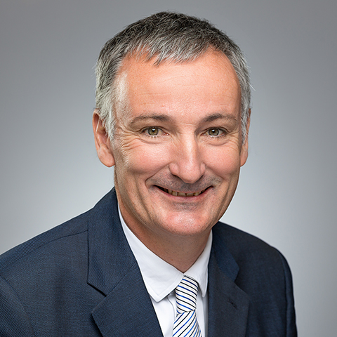
Christophe de la Fouchardière has over 15 years experience in OTC. He was in particular Managing Director Consumer Health Care at Sanofi, in charge of France from 2011 to 2014, then supervising the African continent from 2014 to 2017. He previously held management roles within Merck Médication Familiale France.
Christophe de la Fouchardière holds a Master’s degree in Business Administration from the École Nationale des Ponts et Chaussées.
Strongly engaged with the sector’s professional organisations, he has been a member of the Afipa Board of Directors for over 10 years and has actively participated in the work of the AESGP (Association of the European Self-Medication Industry).
« After 10 years on the Afipa Board of Directors, I wanted to become more involved in the federation. As president of Afipa, I will dedicate my efforts to reinforcing the scope of selfcare in France and to promoting its usefulness with all stakeholders in our sector.
Today, we must re-establish a solid dialogue based on trust with our counterparts: administration, citizens and healthcare professionals – in particular, the pharmacists – who play a crucial role in terms of advice and support to patients in their primary approach to healthcare.
Following the publication of the Competition Authority report regarding the distribution of medicinal products and medical biology, Afipa re-states its position expressed in 2013 following the first Competition Authority report: responsible self-medication can only occur within the safe environment of a pharmacy, with the advice of the pharmacist and his team who are fully trained healthcare professionals and who are experts in medicinal products. This model is key to the patients’ safety and therapeutic education.

We must work closely with our partner pharmacists to co-build a pharmaceutical selfcare process which will ensure its proper use. During my mandate I will devote all my energy to this purpose, with the support of the Board members, the member laboratories and the permanent team » said Christophe de la Fouchardière following his election.

Afipa is the professional federation representing the industrial companies which produce and commercialise health care products available over the counter in pharmacies (self-medication medicine, medical devices and food supplements).
Consult Afipa on:
www.afipa.org
www.masantemonchoix.org
Twitter: @afipa

Self-medication is the possibility for individuals to deal with their illness by taking self-medication medicine which is authorised, over-the-counter, safe and efficient in the use conditions indicated, with pharmacist advice (World Health Organization definition, year 2000).

Press contacts

Sophie CHAMPAUD
01 56 77 16 18 : sophie.champaud@afipa.org

Fiona SALA
01 53 32 28 53 - sala@vianova-rp.com

